**With only rescaling**

sys =

Continuous-time identified state-space model:

dx/dt = A x(t) + B u(t) + K e(t)

y(t) = C x(t) + D u(t) + e(t)

A =

x1 x2 x3 x4 x5

x1 -1.243 -0.0222 -0.007044 0.004487 0.02202

x2 1.069 -0.003397 0.0001022 0.001026 -0.02477

x3 -0.0388 -0.06442 -0.01727 0.01534 -0.01797

x4 -0.5268 -0.6336 -0.1686 0.1556 -0.1799

x5 -1.163 -1.474 -0.3913 0.4097 -0.4807

B =

u1 u2

x1 -0.04699 0.01848

x2 0.04842 -0.0199

x3 0.02436 -0.01226

x4 0.2385 -0.1217

x5 0.6004 -0.3191

C =

x1 x2 x3 x4 x5

y1 -9.128 -11.15 50.86 -5.837 0.4392

y2 -64.59 -73.19 -42.26 7.256 -0.3227

y3 -4.663 -5.871 38.12 -4.573 0.3757

D =

u1 u2

y1 0.0003187 -4.61e-05

y2 -5.282e-05 0.0001118

y3 0.0003697 3.523e-05

K =

y1 y2 y3

x1 0 0 0

x2 0 0 0

x3 0 0 0

x4 0 0 0

x5 0 0 0

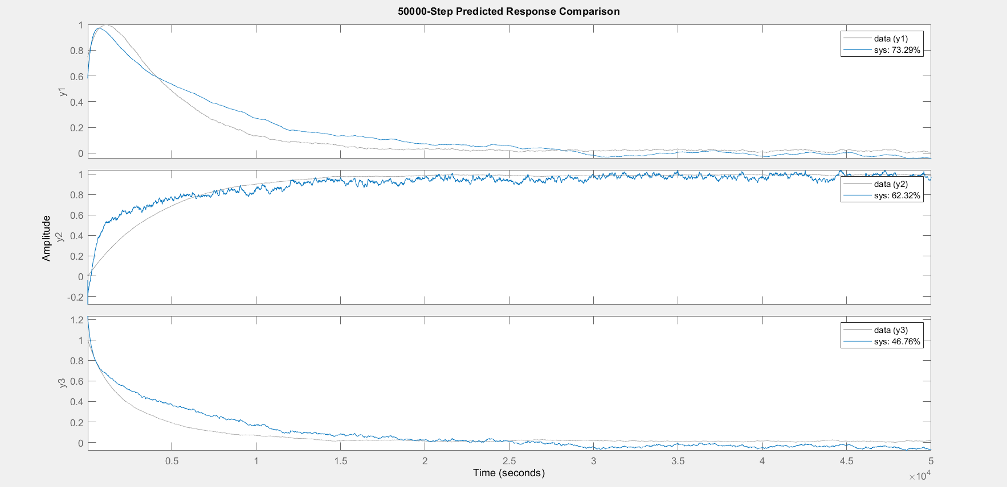

Parameterization:

FREE form (all coefficients in A, B, C free).

Feedthrough: yes

Disturbance component: none

Number of free coefficients: 56

Use "idssdata", "getpvec", "getcov" for parameters and their uncertainties.

Status:

Estimated using N4SID on time domain data "data".

Fit to estimation data: [73.42;57.7;56.63]%

FPE: 1.686e-08, MSE: 0.01413

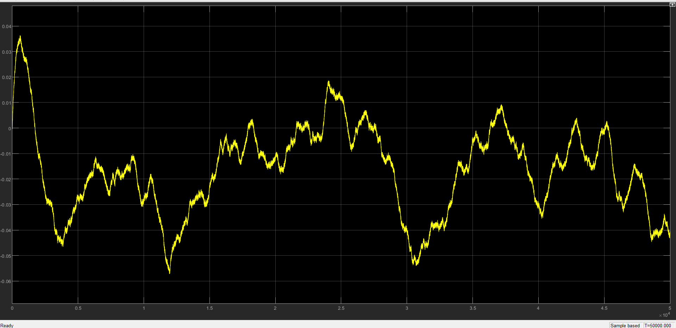

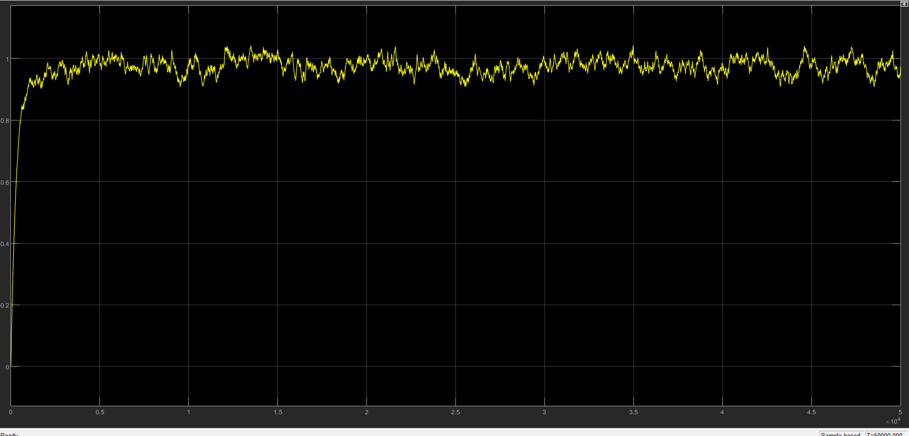

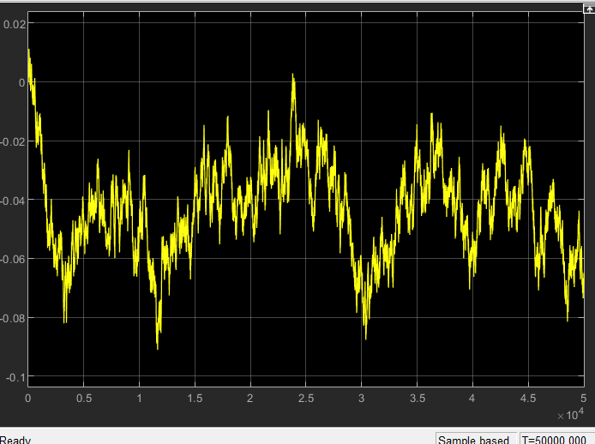

**With rescaling and Y1 smoothed**

sys =

Continuous-time identified state-space model:

dx/dt = A x(t) + B u(t) + K e(t)

y(t) = C x(t) + D u(t) + e(t)

A =

x1 x2 x3 x4 x5

x1 -1.224 -0.01398 -0.005502 -0.001946 0.05773

x2 1.066 0.00671 0.001509 0.003406 -0.0605

x3 0.02668 0.01404 0.007254 0.003808 -0.004923

x4 -0.2646 -0.3052 -0.1836 0.1033 -0.583

x5 -0.6563 -1.002 -0.8481 2.076 -8.322

B =

u1 u2

x1 -0.01528 0.002231

x2 0.00924 -0.001713

x3 -0.0005101 2.933e-06

x4 -0.2381 0.01372

x5 -3.187 0.1818

C =

x1 x2 x3 x4 x5

y1 -9.365 -11.48 60.63 4.383 -0.3264

y2 -64.6 -73.28 -51.48 -1.986 0.254

y3 -4.659 -5.884 43.82 2.95 -0.222

D =

u1 u2

y1 -0.0004406 -3.563e-06

y2 -7.755e-06 3.342e-05

y3 1.967e-05 5.013e-05

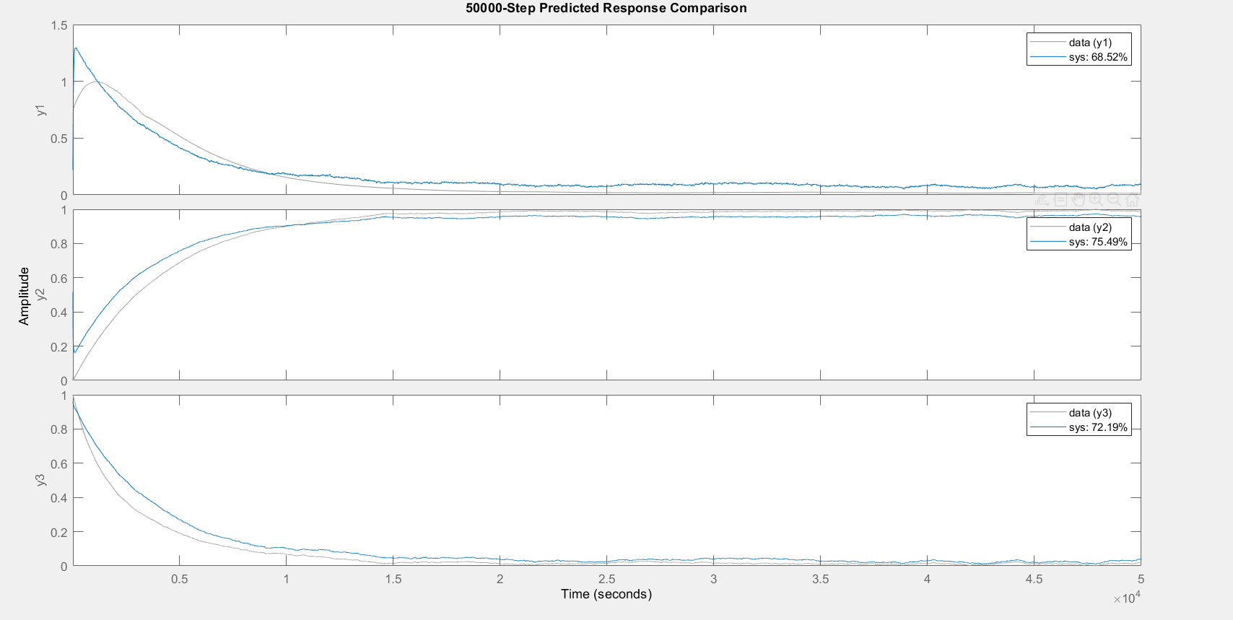

Parameterization:

FREE form (all coefficients in A, B, C free).

Feedthrough: yes

Disturbance component: none

Number of free coefficients: 56

Use "idssdata", "getpvec", "getcov" for parameters and their uncertainties.

Status:

Estimated using N4SID on time domain data "data".

Fit to estimation data**: [74.2;80.76;75.65]%**

FPE: 5.879e-10, MSE: 0.006449

